Twitter and Fake News

Your group will have 15 minutes for this activity. One group member should volunteer to copy this document, share the copy with their group (so that anyone can edit), and read Proposal 1 and Proposal 2 out loud to the group. (In the absence of a volunteer, nominate whoever's last name is alphabetically first!) The group should collectively then answer the questions below, replacing each TODO with the group's collective thoughts.

# Proposals

## Proposal 1

Twitter relies on an algorithm as well as individual users’ reports to identify content that is potentially "fake news." Once the content has been identified, it is sent to third-party fact-checkers for verification. If the content is verified as fake news, it is publicly flagged with a warning that the content is disputed by fact-checkers.

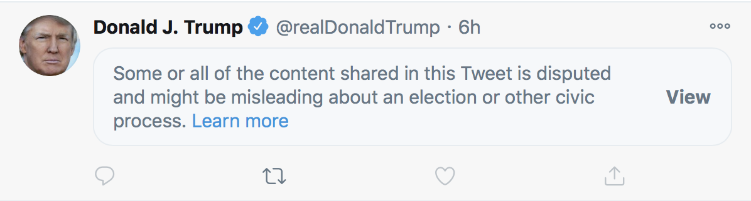

## Proposal 2

However, a designer at Twitter believes that there needs to be a different approach to content regulation. Their proposal is that instead of simply flagging content that spreads misinformation, there should also be a link that takes the user to a more credible source of information.

# 

## **Five Rights and Opportunities for a Democratic Public Sphere**

# **Rights**. As citizens of a democracy, we have rights to basic liberties, such as liberties of expression and association. The right to expressive liberty is important not only for the freedom of the individual, so that he or she is not censored, but also for democracy itself. It enables citizens to bring their ideas into conversation with one another, and to criticize and hold accountable those who exercise power.

# **The opportunity for Expression**. Not only should we be free of censorship but we should have fair opportunity to participate in public discussion. It shouldn't be the case that because someone is wealthier or more powerful that they should have more opportunity to participate.

# **Access**. Each person should have good and equal access to quality and reliable information on public matters. That is, IF we make the effort, we should be able to acquire this information. Effective participation in decision making on public matters requires being informed.

# **Diversity**. Each person should have good and equal chances to hear a wide range of views. We need access to competing views in order to have a more informed and reasoned position.

# **Communicative power**. Citizens should have good and equal chances to explore interests and ideas in association with others, and through these associations, to develop new concerns that challenge the mainstream view.

# 

# Questions

1. Which form of content regulation, Proposal 1 or Proposal 2, do you feel is better? Why?
   1. TODO
2. Which form of content regulation, Proposal 1 or Proposal 2, do you think best preserves or promotes the [five rights and opportunities necessary for a democratic public sphere](https://cs50.harvard.edu/college/2020/fall/labs/10/lecture/#five-rights-and-opportunities-for-a-democratic-public-sphere)?
   1. Which proposal best preserves or promotes Rights? Why?
      1. TODO
   2. Which proposal best preserves or promotes Opportunity for Expression? Why?
      1. TODO
   3. Which proposal best preserves or promotes Access? Why?
      1. TODO
   4. Which proposal best preserves or promotes Diversity? Why?
      1. TODO
   5. Which proposal best preserves or promotes Communicative Power? Why?
      1. TODO